Compassionate care at home. Across Annandale & Eskdale
For you, with you, near you.
What’s New
As an organisation we aim to make the lives of our users a little bit easier. This may be providing visiting care, 24hr care, companionship or much needed respite to a carer at home. We have recently launched a new website and page to make accessing our services easier. We hope to continue supporting our service users to live independently at home for as long as possible. Please feel free to contact us to discuss any care needs you may have.

Upcoming Events
Monday 8th June, Loreburn Hall, Dumfries 10am-2pm
- “Supporting Carers, Building Communities”
    - Health & NHS Services
    - Social Work Teams
    - Third Sector and voluntary organisations, including ourselves
    - Community groups & support Services
  - Alzheimer’s Scotland Group Meetings
    - “Brydekirk Buddies” Brydekirk Village Hall, every Wednesday 10-12 noon
    - Lockerbie Let’s get together, Hartnell’s Café, Trinity Street, Lockerbie, every Tuesday 11.00-1.30pm

Training Available
Becoming an unpaid carer can often feel overwhelming in many ways. We work alongside CTC to ensure all our staff are fully trained in all necessary areas. CTC also offer free training for unpaid carers to access, this can help with not only the physical challenges of caring at home but essential knowledge that helps in the role.
Please contact Cheryl Murray (07918258781) to book your space
- Support with moving and handling
- One-to-one support for complex care needs
- First Aid

“My dream was to get
outside again
Crossroads made it happen”

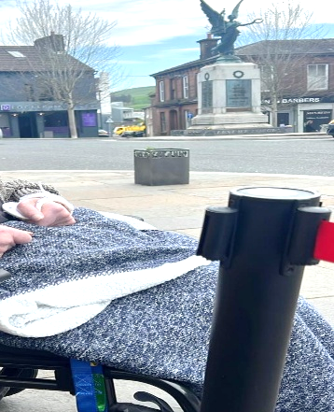

1574 hours of care at home support in April 2026

